**BANK MANAGEMENT SYSTEM IN JAVA**

**FINAL PROJECT REPORT**

**(IDS/ICS - 353)**

Degree

**B. TECH IN CSE**

**(In Collaboration with I Nurture)**

|  |  |
| --- | --- |
| Project Guide:  **Mr. Ghufran Khan**  **Mentor, IT**  **HOD, I Nurture, TMU** | Submitted By:  **Krish Vishnoi (TCA2266006)**  **Suhel Khan (TCA2250008)**  **Piyush Kumar Jha (TCA2250007)** |

Aug – 2023, Dec - 2023



COLLEGE OF COMPUTING SCIENCE AND INFORMATION TECHNOLOGY

TMU, MORADABAD

**Table of Contents**

1 Project Title 3

2 Domain 3

3 Introduction 3

4 Problem Statement 3

5 Project Description 4

5.1 Project Modules 4

6 Implementation Methodology 4

7 Technologies to be used 13

8 Advantages of this Project 13

9 Future Scope and further enhancement of the Project 13

10 Team Details 14

11 Conclusion 14

# Project Title

**" BANKING APPLICATION IN JAVA"**

* The banking management system is an application for maintaining a person's account in a Bank.
* This project has facility to create an account, to see account details, Balance Enquiry, List of all accounts, and Transaction money, etc.

# Domain

* To develop a software for solving financial applications of a customer in banking environment in order to nurture the needs of an end banking user by providing various ways to perform banking tasks.
* Also, to enable the user’s workspace to have additional functionalities which are not provided under a conventional banking software in this project we are going to explain about: - Banking Management System.

# Introduction

• **This project is to create an online banking system for banks, as the current system relies on manual processes for all banking work, such as create an account, Money Deposit, Withdraw Money, Balance Enquiry and for List of all accounts.**

# Problem Statement

* In any Bank Transaction, there are several parties involved to process transaction like a merchant, bank, receiver, etc.
* So, there are several numbers reasons that transaction may get failed, declined, so to handle a transaction in Java, there is a JDBC (Java Database Connectivity) which provides us an API (Application Programming Interface) to connect, execute, fetch data from any databases. It provides the language Java database connectivity standards. It is used to write programs required to access databases

# Project Description

* The Bank management system is an application for maintaining a person’s account in a bank.
* The system provides the access to the customer to create an account, deposit/withdraw the cash from his account, also to view reports of all accounts present.
* The following presentation provides the specification for the system.

## Project Modules

* This Bank Application System has been designed to overcome all the disadvantages of the traditional banking system. A user has the option of creating an account, cash transactions all at their own discretion. There is a separate module for each and every action
* Bank Application System Modules

* + This module lets users add a new account by providing name, address and age.
  + This module provides to knowing your KYC status is completed or not.
  + This module has been designed to assist the users in depositing money. It takes as input account number, type, date and amount.
  + This module provides account information, balance, withdrawal and deposit information. It has four sub-modules:
  + This displays the information of the account whose number has been entered into the given field
  + This displays the current balance in the queried account
  + This shows the logs of the deposits which have been made into the account.
  + This module shows the logs of the withdrawals that have been made from the account.
  + This module has been designed to assist the users in withdrawing money. It takes as input account number, type, date and amount.
  + This lets user to delete an existing account.

# Implementation Methodology

* In this section, we will learn how to create a mini-application for a banking system in Java. In this program, we will add some basic functionalities of a bank account like a deposit of amount, withdrawal of amount, etc. Initially, the program accepts the number of customers we need to add and adds the customer and account details accordingly. Further, it displays the series of menus to operate over the accounts.
* The series of menus displayed are as follows:

1. Create Account
2. Deposit
3. Withdraw
4. Balance Enquiry
5. List of All Accounts
6. Exit

**Source Code: -**

1. **Account.java**

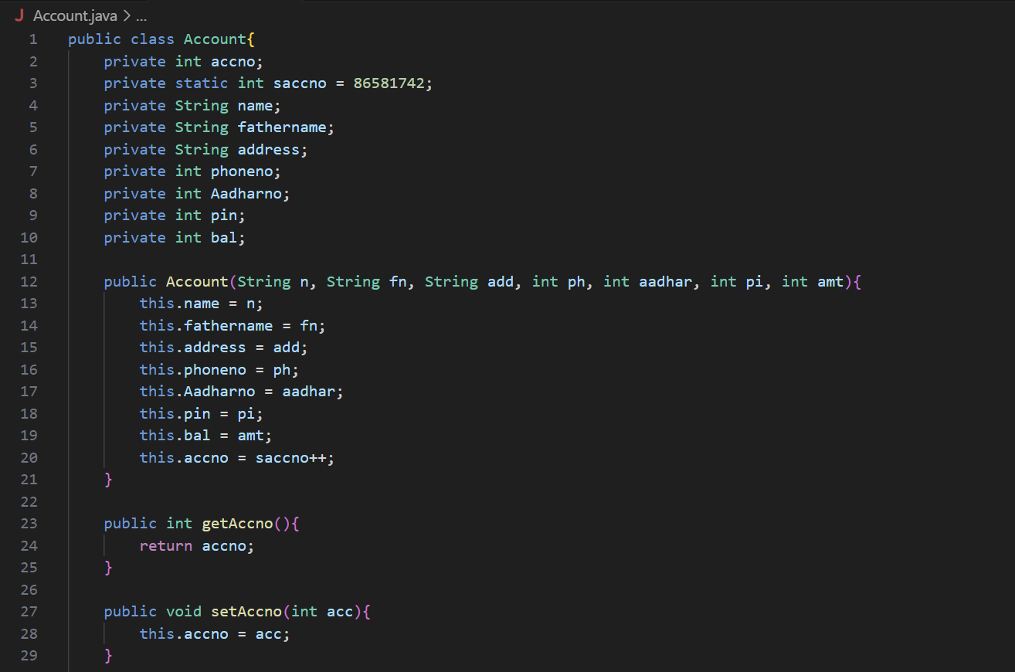

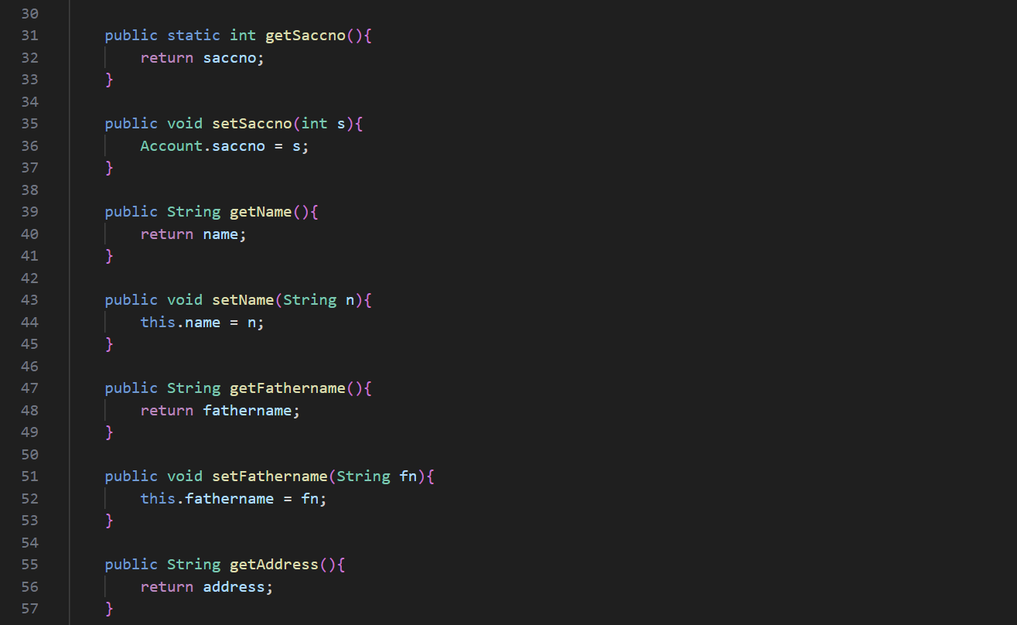

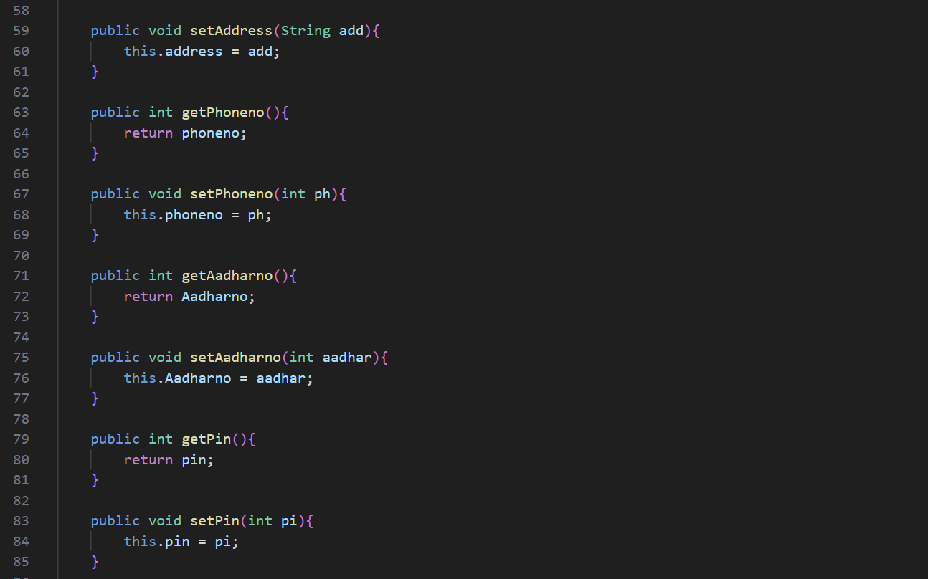

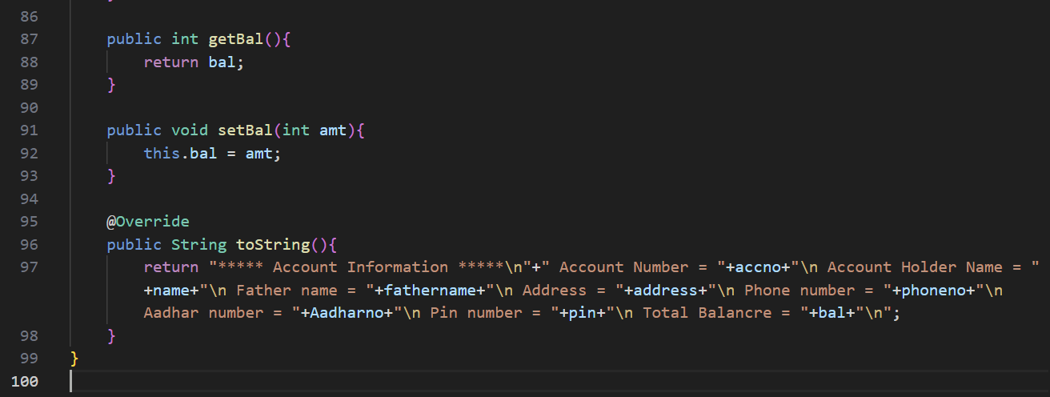

1. **BankApp.java**

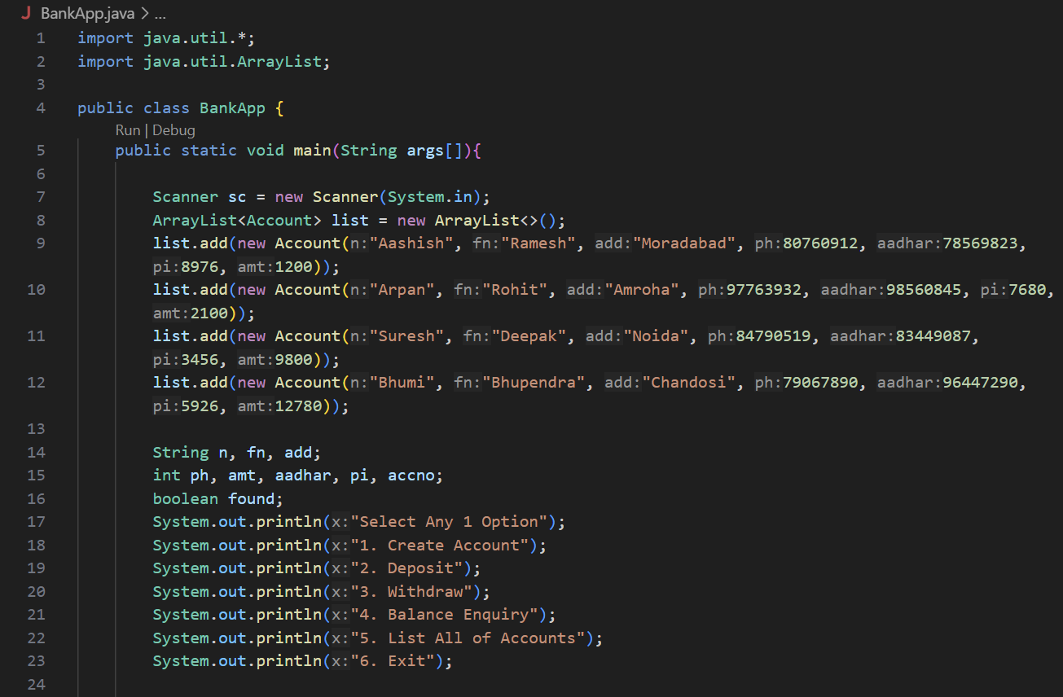

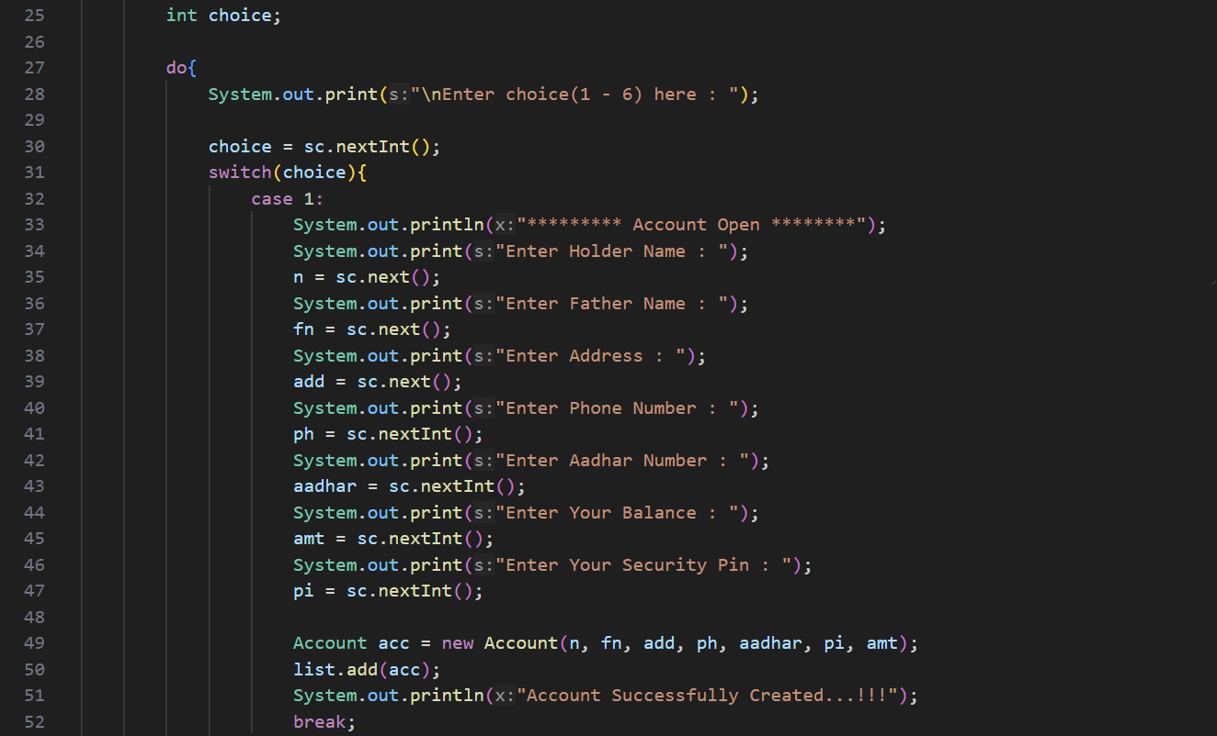

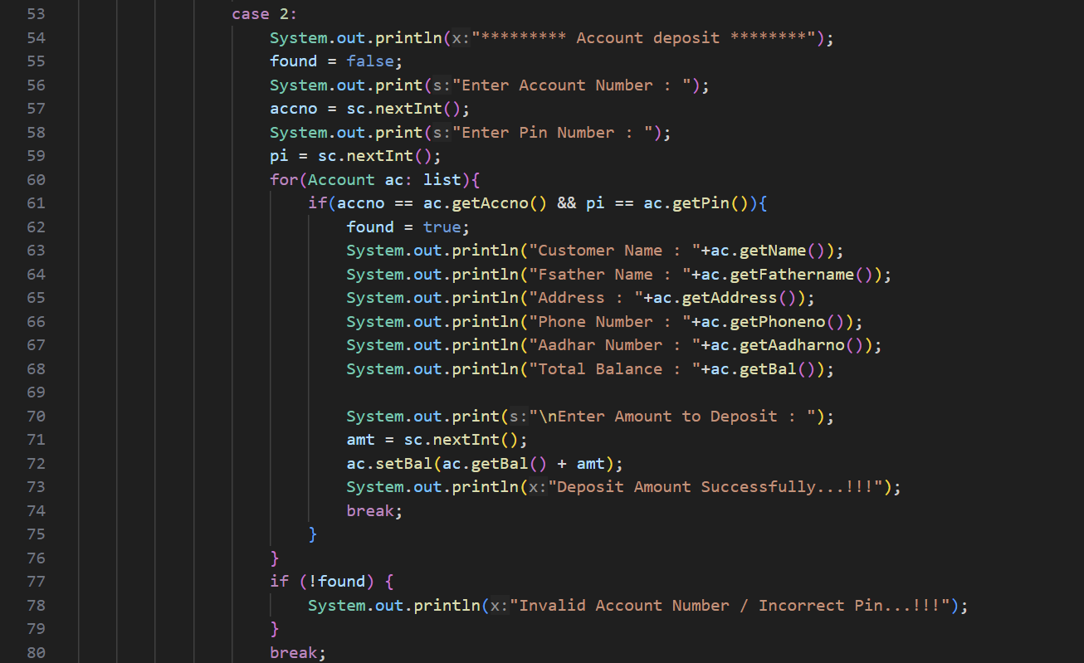

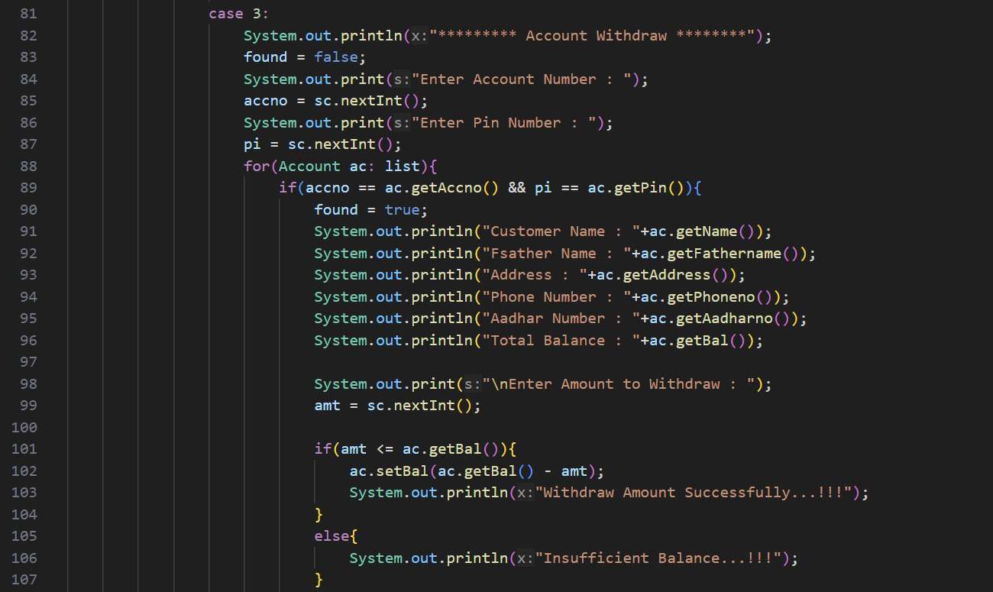

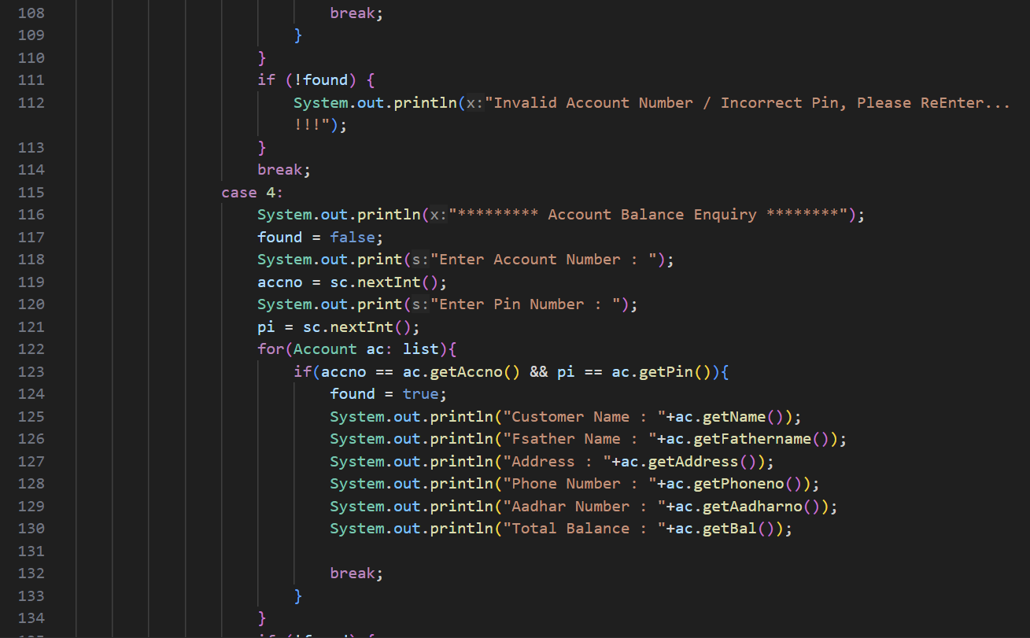

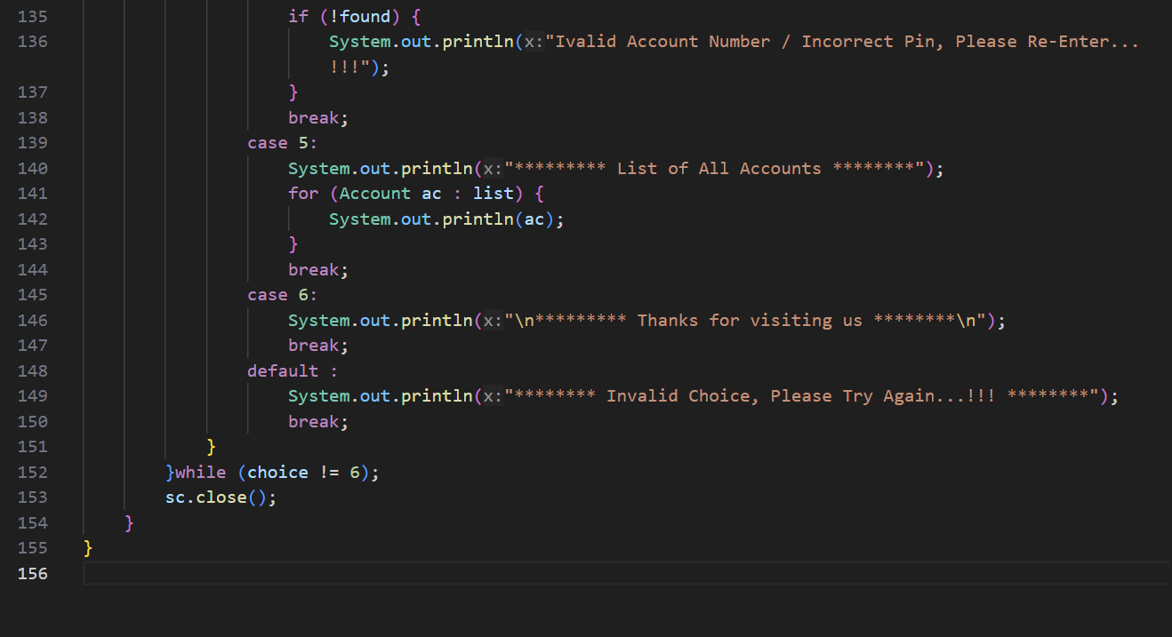

**Output: -**

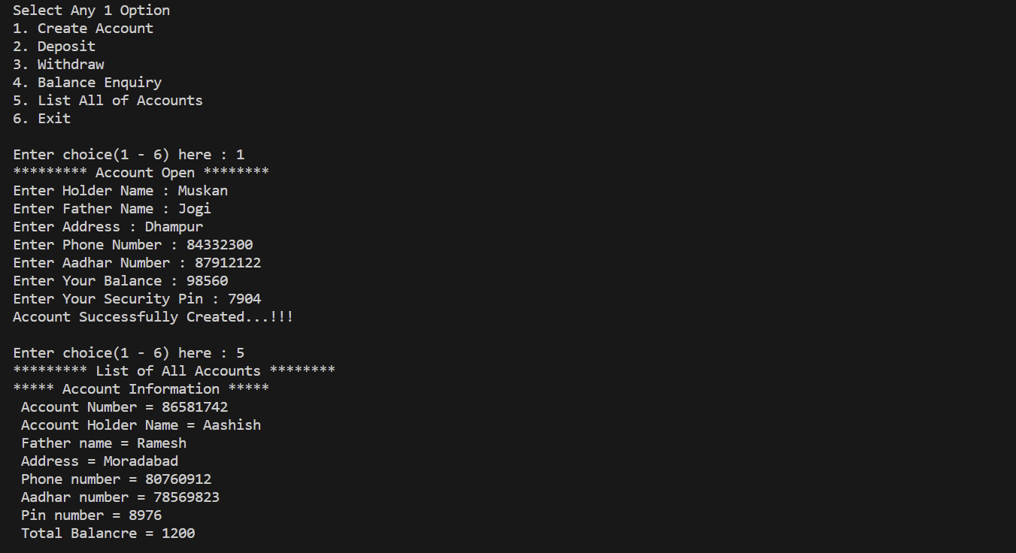

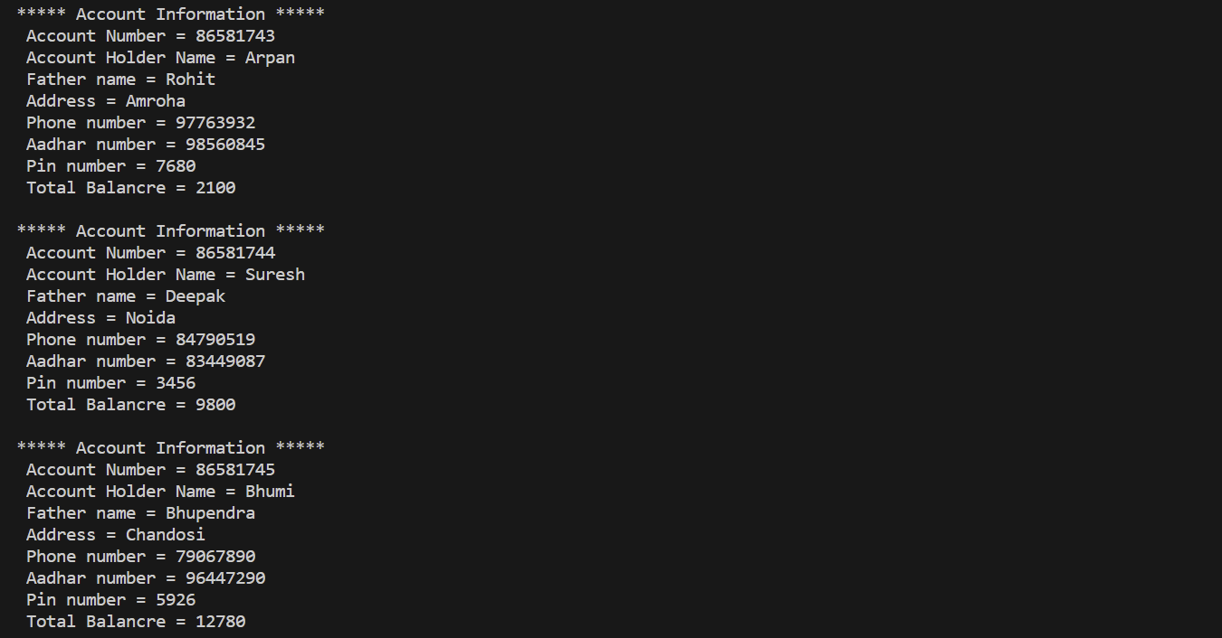

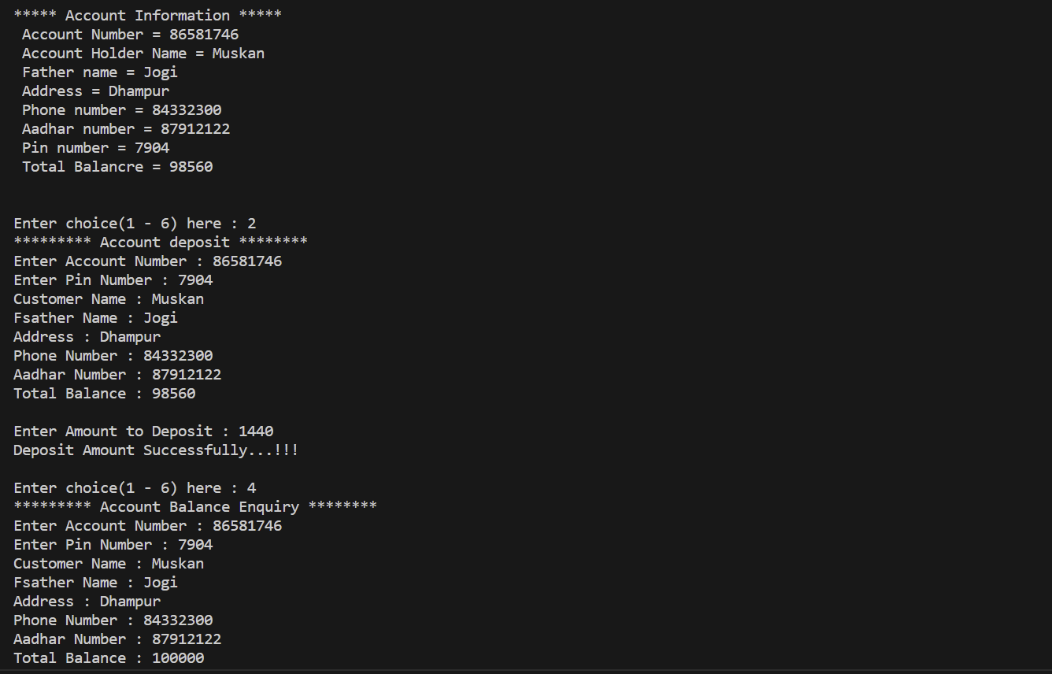

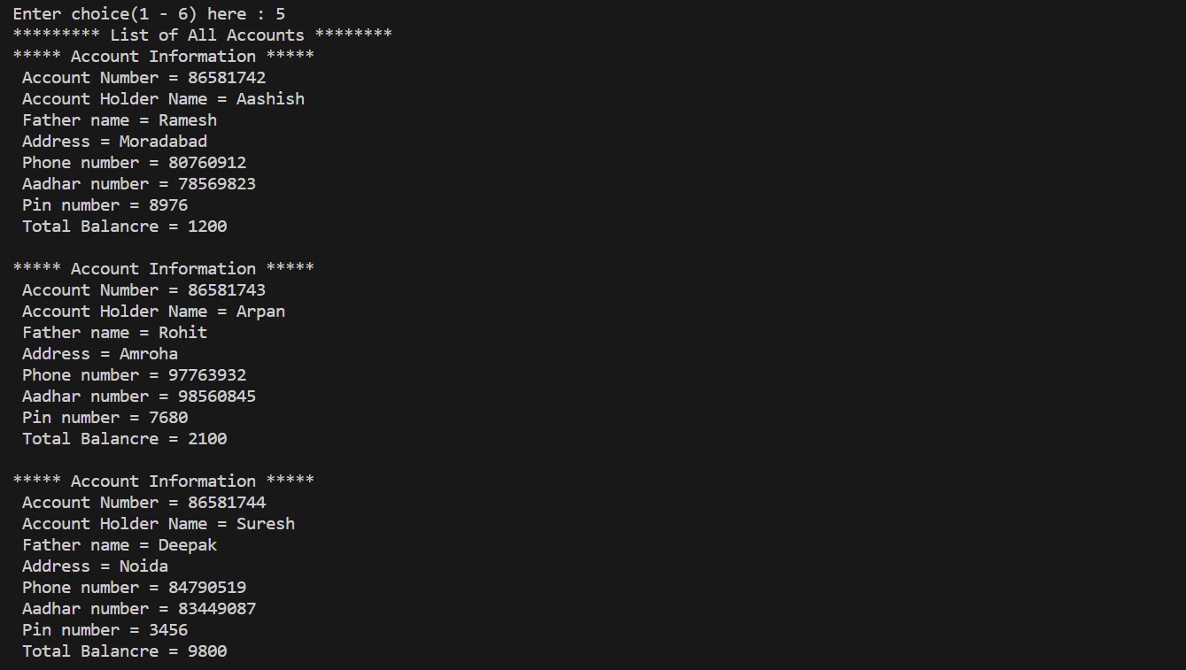

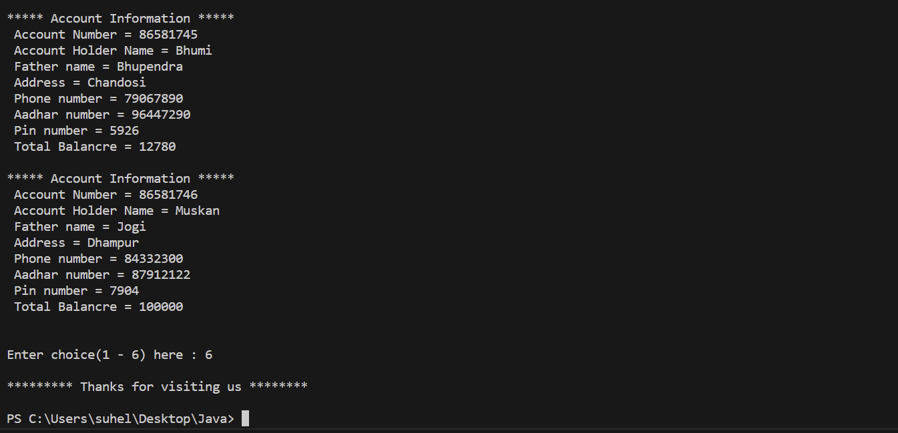

# Technologies to be used

1. **Software Platform**
   1. **Back-end – JAVA**
2. **Hardware Platform**

16GB RAM, 512GB SSD, Window O/S, Visual Studio Code Editor, etc.

# Advantages of this Project

* The manual Bank Application System that carries out the whole process in a bank are more prone to errors.
* It takes a vast amount of time to take an action be it the creation of an account or depositing money.
* It is especially negative when there are time constraints for the customers to get a work done.
* This makes it a lot inconvenient for the customer as well as it is time consuming.
* Banks are open only in limited hours in a day and any transaction to be made after those times in cases of emergencies become impossible. This causes a lot of inconvenience

# Future Scope and further enhancement of the Project

• Today's online banking customers enjoy instant access from their computer or mobile device to a full range of services, allowing you to: Check balances on accounts and view records of your transactions. Pay bills automatically each month with easy-to-setup auto payment. Transfer funds between accounts.

# Team Details

|  |  |  |  |  |  |
| --- | --- | --- | --- | --- | --- |
| Project Name & ID | Course Name | Student ID | Student Name | Role | Signature |
| **BANK**  **MANAGEMENT**  **SYSTEM**  **IN JAVA** | **MINI PROJECT LAB**  **(IDS/ICS-353)** | TCA2266006 | KRISH VISHNOI | PRESENTOR, DEVELOPER |  |
| TCA2250008 | SUHEL KHAN | DESIGNER,  CODER |  |
| TCA2250007 | PIYUSH KUMAR JHA |  |  |

# 

# 11 Conclusion

• In this project we have added the facility to perform Balance Enquiry, to see the all accounts details, Deposit Money, Withdraw Money and many more so that the person will not be needed to visit the bank branch for these purposes.